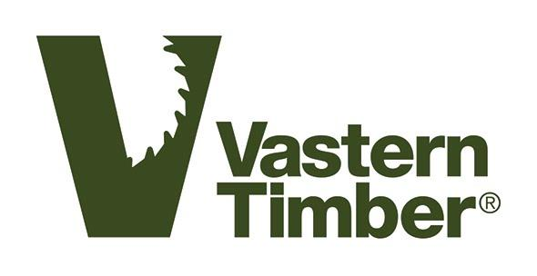

Timber Purchasing Policy
Last amended 15/12/2021

Our Responsibility
We understand that we have a responsibility to the environment, our staff, customers and suppliers.

This means we will do our best to:

- Base our commercial activities on wood sourced from well-managed local woodlands.
- Source wood from forests accredited under either PEFC or GIB schemes.
- Avoid timber from contentious sources.
- Minimise the effects of transportation through local purchasing.
- Support the management and creation of British woodlands.
- Play a positive and productive part in the UK forestry and timber industries.

Legality
We are committed to complying with UKTR legislation by identifying the source of all the timber we buy, as well as taking all reasonable measures to ensure that we do not purchase illegally harvested material under any circumstances.

Supplier Monitoring
We will regularly obtain from suppliers:

- Up to date forestry management plans.
- The clearest practicable information regarding the source of logs.
- Current chain of custody certificates.

All information received will form part of our purchasing decisions and we will make this information available on request.

Timber Certification
The independent certification of forests, and process chain, is the most useful tool in providing assurances that timber comes from legal and well-managed forests. We are currently committed to the PEFC and GIB certification schemes. We have made a conscious decision not to continue our association with the FSC scheme.

We will only use labels or certificates that include environmental claims if these are supported by publicly available standards, drawn up in a fully participatory, transparent and objective manner. These must also be backed by independent inspection.

Avoiding Misleading Claims
We will avoid misleading and unsubstantiated environmental claims.

Management Structure
Tom Barnes is responsible for the implementation of this policy. He will ensure that environmental issues relevant to the policy are discussed regularly at the highest level of management.

Tom Barnes will ensure that all employees associated with timber purchasing are encouraged to act in accordance with this policy. When needed, he will provide team members with the appropriate education and training to do so.

Tom Barnes
Managing Director

